Easy:

1. You are on a strange planet. You note that the stars do not rise and set but circle around in planes parallel to the horizon. You then set out on a journey which takes you a straight line (really a great circle) for 15000 km and find that the stars now rise and set perpendicular to the horizon. What is the radius of the planet?(answer in km)

A). 8250 B). 9550 C). 12600 D). 14750 E). 4000 (B)

1. (Still on the same planet as in problem 1)

You now drop a stone from a height of 2m and measure the time the stone takes to fall to the ground, which is 0.52 seconds. What is the mass of the planet?

A). 5 \* 10 24 B). 1 \* 10 25  C). 2 \* 1025 D). 4 \* 1025

(C)

1. A space ship is moving around a planet near its surface with the density of the planet is x. The space ship’s engine is off (means the only force on it is the gravity force ) and its angular velocity is y. Find out the relation ship between x and y. (Keep all the constants you use)

y = root(4\*G\*x)

Medium :

1. Hercules was having a hard time cleaning the stables one morning. So he rigged up two pulleys (1,2) and two pieces of rope(A,B) in the cunning arrangement shown below. By pulling down on the free end of rope A, the force was multiplied by some factor and applied upwards on the load. Calculate the factor, given ideal equipment.
2. . 1 B). 2 C). 2.5 D). 3 E). 4

(D)

1. The same block is sliding down the hill three times on three different incline a, b and c. All of them have the same coefficient of friction. Which way will make the final velocity highest ?

A). a B.) b C). c D). Same E). Can’t tell

(D)

1. An athlete rows at a constant speed with respect to the water, up stream. Just as he passes a bridge his lunch falls off the seat of the boat into the water. He had previously learned the motto “Better glad than mad” and as a result, The lunch in its water tight container gloats downstream with the current. How fast is the river flowing it it is assumed to be constant?

A). 3 km/hr B). 2 km/hr C). 6 km/hr D). 1.5 km/hr E). 1 km/hr

(A)

Hard:

1. A simi-circle block ACB, its point of mass is on point O and its mass is 1000kg. It is fixed on a and out on a ball. Another block D with mass 500 kg is sliding down with out friction. Find the force from A and B. (Hint: the force on A can be any direction but the force on be can only be vertically)

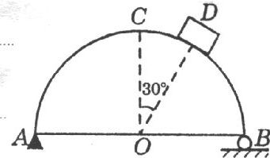

2. Find an example that shows friction force can do positive work.